**CLIMATE CHANGE PROJECT SQL QUERIES**

1. **Data Cleaning:**

**-- Create a combined Table**

create table "Climate Change"."Combined Data" as

select * from "Climate Change"."Australia"

union

select * from "Climate Change"."Brazil"

union

select * from "Climate Change"."Canada"

union

select * from "Climate Change"."Germany"

union

select * from "Climate Change"."India"

union

select * from "Climate Change"."South Africa"

union

select * from "Climate Change"."USA"

**--Showing the table**

select * from "Climate Change"."Combined Data"

**-- Check for Duplicates**

Select "Record ID"

from "Climate Change"."Combined Data"

group by "Record ID"

having count(*) > 1;

**-- showing just the country column the dataset**

select distinct "Country"

from "Climate Change"."Combined Data"

**-- update the country name**

update "Climate Change"."Combined Data"

set "Country" = 'India'

where "Country" = 'Inda'

**-- Check for the null values**

select * from "Climate Change"."Combined Data"

where "Record ID" is null

or "Country" is null

or "Date" is null

or "City" is null

or "Humidity" is null

or "Precipitation" is null

or "AQI" is null

or "Extreme Weather Events" is null

or "Climate Classification" is null

or "Climate Zone" is null

or "Biome Type" is null

or "Heat Index" is null

or "Wind Speed" is null

or "Wind Direction" is null

or "Season" is null

or "Population Exposure" is null

or "Economic Impact Estimate" is null

or "Infrastructure Vulnerability Score" is null;

**-- update pop exposure to fill in the null value with average**

update"Climate Change"."Combined Data"

set"Population Exposure" = (

SELECT AVG("Population Exposure")

FROM "Climate Change"."Combined Data"

WHERE "Country" = 'Australia' AND "Population Exposure" IS NOT NULL

)

WHERE "Record ID" = 'aus_1338';

**-- update city to fill in the null value with the previous/after city**

update"Climate Change"."Combined Data"

set"City" = 'Toronto'

WHERE "Record ID" = 'cnd_227';

1. **Data Analysis**

**-- Monthly Temperature Trends**

select TO_CHAR ("Date",'Month') as Month_Name,

avg("Temperature") as Avg_Temperature

from "Climate Change"."Combined Data"

group by TO_CHAR ("Date",'Month'), extract (month from "Date")

order by extract (Month from "Date");

-- jan has the highest avg temp while march has the lowest

-- mar and nov have low indicating seasonal cooling months

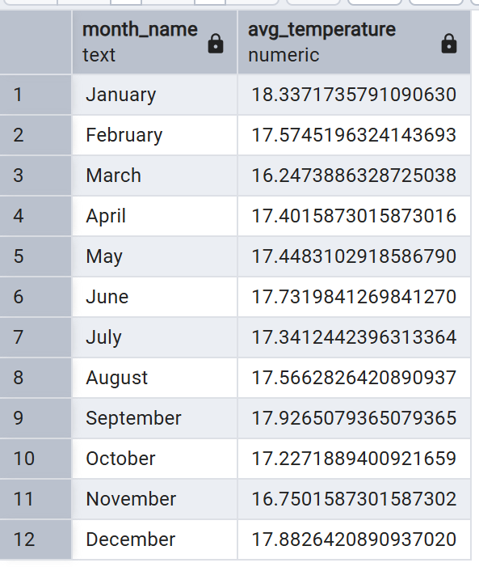

**-- average the temp by country**

select "Country",

avg("Temperature") as Avg_Temperature

from "Climate Change"."Combined Data"

group by "Country"

Order by Avg_Temperature desc;

-- Canada has the highest and germnay the lowest

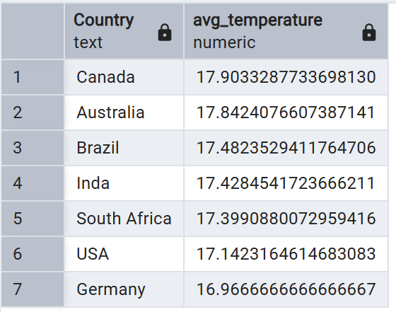

**-- Extreme weather events over time**

select to_char("Date", 'Month') as Month_Name,

count(*) as Event_count

from "Climate Change"."Combined Data"

where "Extreme Weather Events" <> 'None'

Group by to_char("Date", 'Month')

order by min("Date");

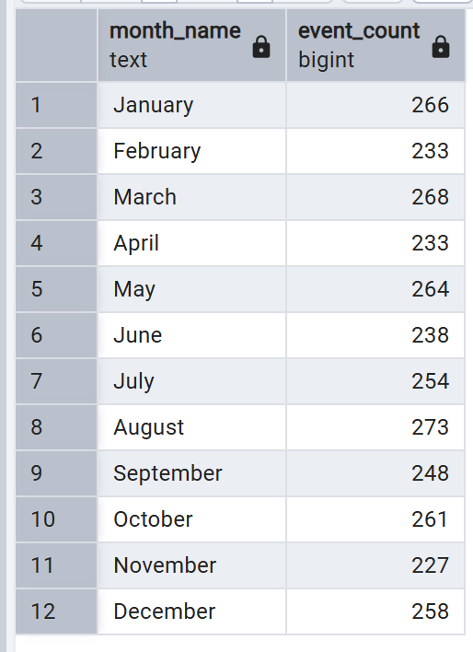

**-- country wise extreme events**

select "Country",

count(*) as Event_Count

from "Climate Change"."Combined Data"

where "Extreme Weather Events" <> 'None'

group by "Country"

order by Event_count desc;

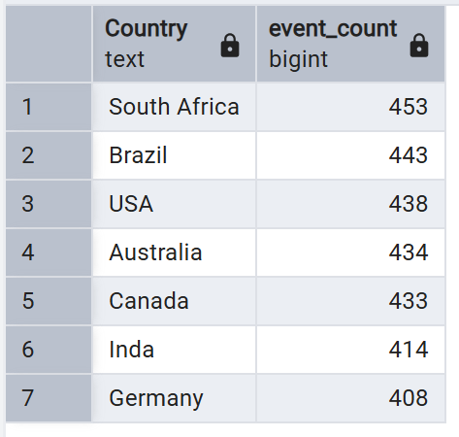

**-- Relationship between temperature and extreme weather events**

SELECT

CASE

WHEN "Temperature" < 10 THEN 'Very Cold (<10°C)'

WHEN "Temperature" BETWEEN 10 AND 15 THEN 'Cold (10-15°C)'

WHEN "Temperature" BETWEEN 15 AND 20 THEN 'Moderate (15-20°C)'

WHEN "Temperature" BETWEEN 20 AND 25 THEN 'Warm (20-25°C)'

ELSE 'Hot (>25°C)'

END AS Temperature_Range,

"Extreme Weather Events",

COUNT(*) AS Event_Count

FROM "Climate Change"."Combined Data"

WHERE "Extreme Weather Events" <> 'None'

GROUP BY Temperature_Range, "Extreme Weather Events"

ORDER BY Temperature_Range, Event_Count DESC;

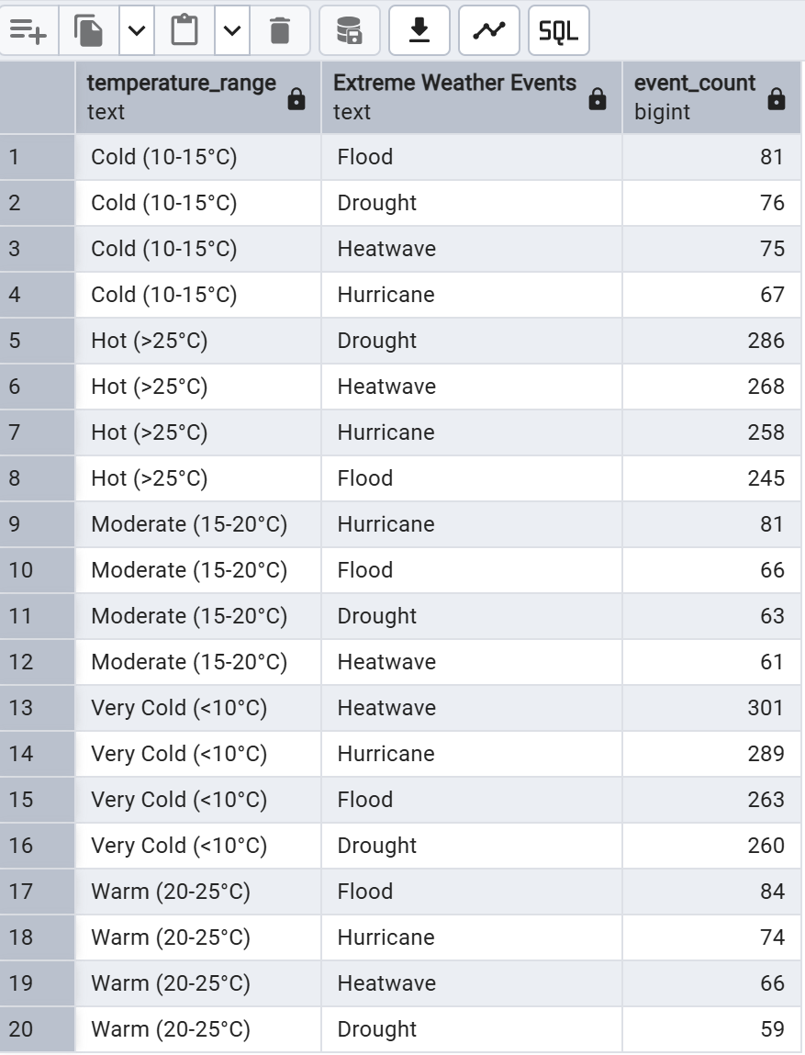

**-- which cities are experiencing extreme weather events are what are the economic and population impacts**

select "Country", "City", "Extreme Weather Events",

count(*) as "Event Type",

Round(avg("Temperature"), 1) as "Average Temperature",

sum("Population Exposure") as "Total Population Exposure",

sum("Economic Impact Estimate") as "Total Economic Impact",

round(avg("Infrastructure Vulnerability Score"), 0) as "Average Vulnerability"

from "Climate Change"."Combined Data"

where "Date" between '2025-03-03' and '2025-03-07'

and "Extreme Weather Events" != 'None'

group by "Country", "City", "Extreme Weather Events"

order by "Total Economic Impact" desc;

-- climate change is making extreme weather events more frequent requiring immediate adaptation strategies

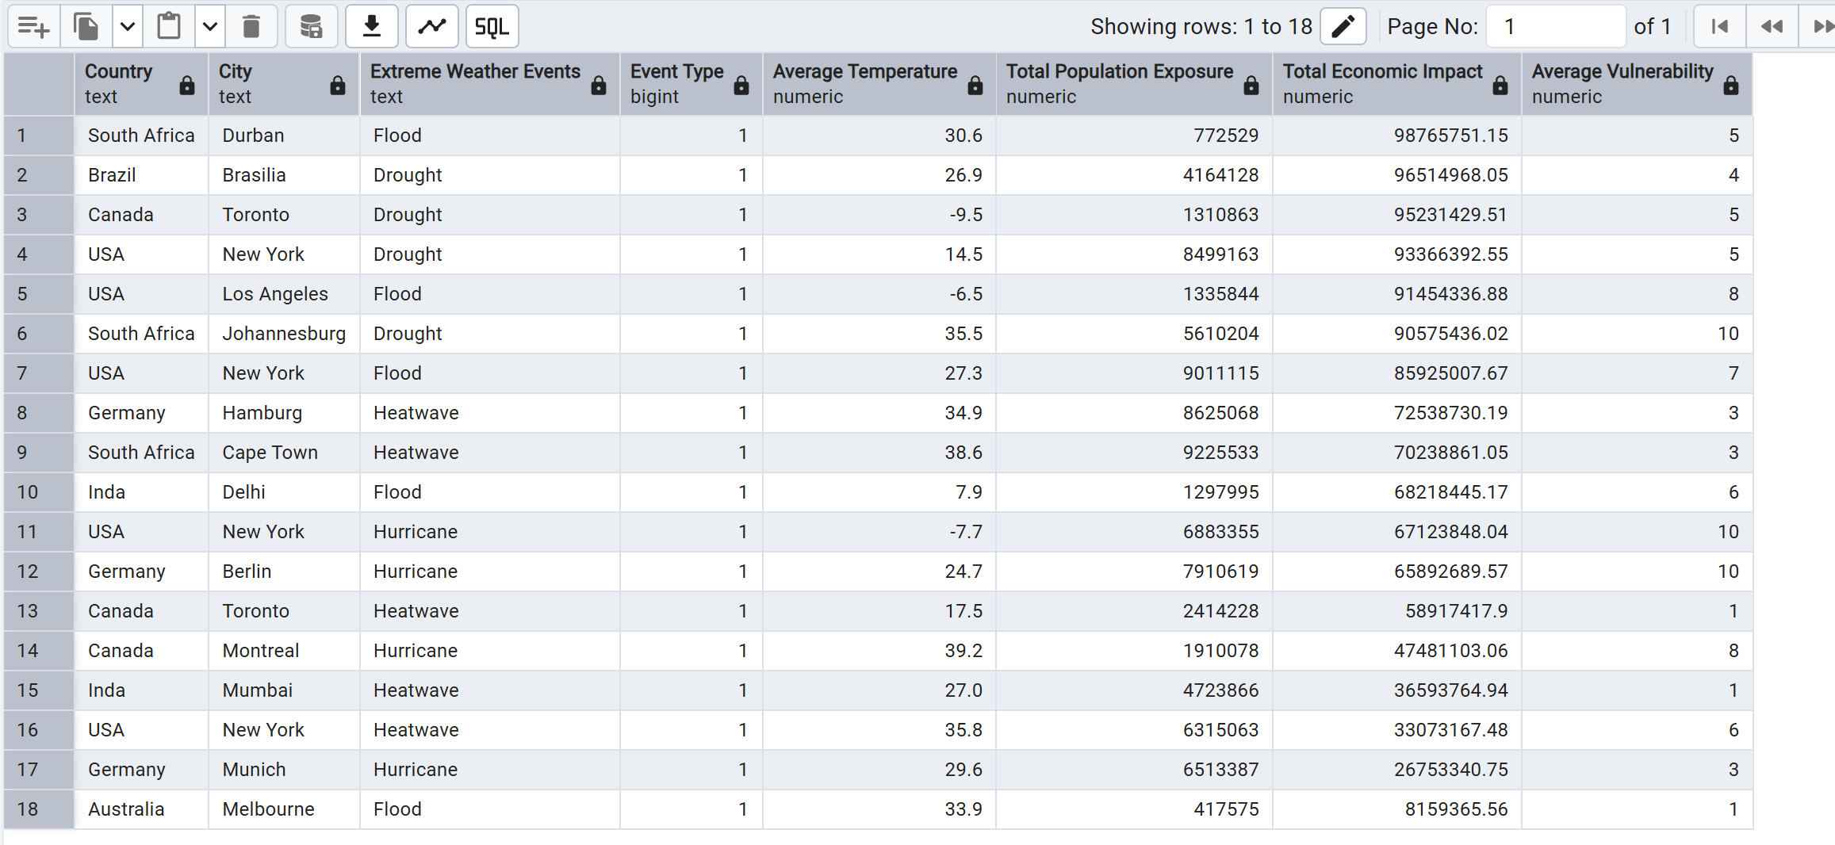

**-- what are the top 5 cities with the highest air quality concerns and their associate risks?**

select "Country", "City",

round(avg("AQI"), 0) as "Average AQI",

count(*) as "Days above 200 AQI",

SUM("Population Exposure") as "Total Population Exposure",

round(avg("Temperature"), 1) as "Average Temperature"

from "Climate Change"."Combined Data"

where "Date" between '2025-03-03' and '2025-03-07'

group by "Country", "City"

having avg("AQI") > 100

order by "Average AQI"

limit 5;

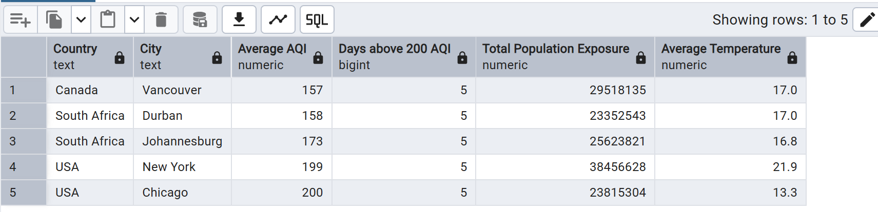

**-- Which biome types are most risk from extreme weather events this week?**

select "Biome Type",

count(*) as "Total Records",

count(distinct concat("Country", "City")) as "Locations Affected",

count(case when "Extreme Weather Events" != 'None' then 1 end) as "Extreme Weather Count",

STRING_AGG(DISTINCT "Extreme Weather Events", ', ') as "Event Types",

Round(avg("Temperature"), 1) as "Average Temperature",

sum("Economic Impact Estimate") as "Total Economic Impact Estimate",

Round(Avg("Infrastructure Vulnerability Score"), 0) as "Average Vulnerability"

from "Climate Change"."Combined Data"

where "Date" between '2025-03-03' and '2025-03-07'

group by "Biome Type"

